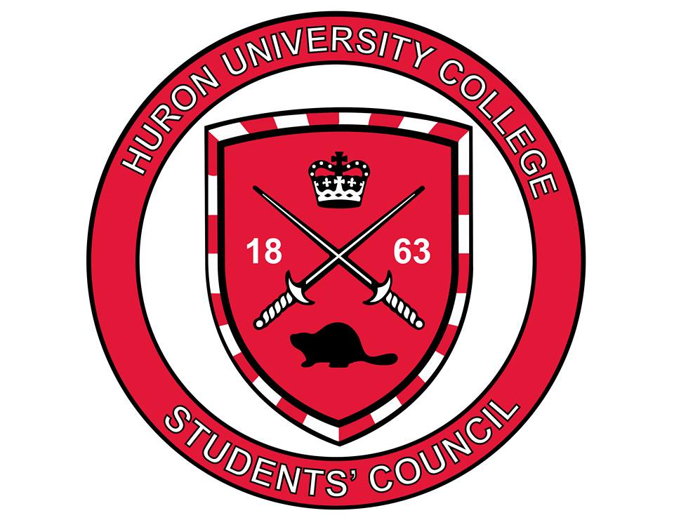
Vice-President Student Events Portfolio

Position Opening: Special Events Commissioners (2)

Direct Supervisor: VP Student Events

Compensation: Not eligible for compensation

Position Description:
Work with the VP Student Events to execute new and existing social events for the Huron student body during the 2018/2019 academic year. This will include events such as the Blue Jays game, bar nights, apple & pumpkin picking, HBK events, late night soup sampling, and more.

Responsibilities:
- Assist in the planning and execution of social events that have been approved by the VP Student Events.
- Analyze feedback from the Huron student body and pitch new ideas for social programming that may improve student experience and engagement at Huron.
- Communicate with external organizations and venues on behalf of the portfolio to organize each event.
- Maintain relationships with the VP Communications, International Student Leaders, and other stakeholders of the portfolio to ensure proper support and collaboration from these channels.
- Complete an interim report at the end of the fall academic term and a final report at the end of the winter academic term

Relevant Skills:
- Collaborative work ethic
- Excellent organizational and critical thinking skills
- Communicates effectively through written and oral mediums
- Enthusiasm and passion for Huron and the position
- Ability to take direction and initiative
- Prior event planning and project management experience
- Being in London for the summer is an asset, not required

Application Requirements: Application Form and Resume

